First Draft: Blackbox Version Fingerprinting of
Routers and Network Services
Design report: architecture, contributions, competitive positioning, and threats to validity

1. Problem and objective
The work recovers the exact software version of a networked device, a router or a widely deployed service, from the outside, without access to its firmware, credentials, or internal state. The motivation is a measurement gap. Exposure platforms such as Shodan and Censys assign a product and a version to every host they index, yet the version they report is frequently coarse or wrong. A wrong version label propagates downstream, because it feeds directly into the vulnerability set that is attributed to the host through the NVD and CPE mapping. The objective is therefore twofold. The first part establishes whether a version can be distinguished from the outside at all, and under which protocols. The second part quantifies how often the public labeling is incorrect and what that error implies for vulnerability attribution.
One principle governs every stage. Discovery is separated from judgment. A language model is allowed to propose candidate signatures, because proposing is a search problem where breadth helps. A deterministic procedure then decides which proposals survive, because a claim about a version must be reproducible and must not rest on a model's confidence. No signature enters the final result unless a deterministic rule confirms it on data the discovery step never saw.

2. Architecture
The diagram below shows the full pipeline. Inputs enter at the top, the emulation laboratory sits in the dashed region, and the analysis path runs down the center. Language-model stages and retrieval stores appear only at the edges, never inside the detection core.
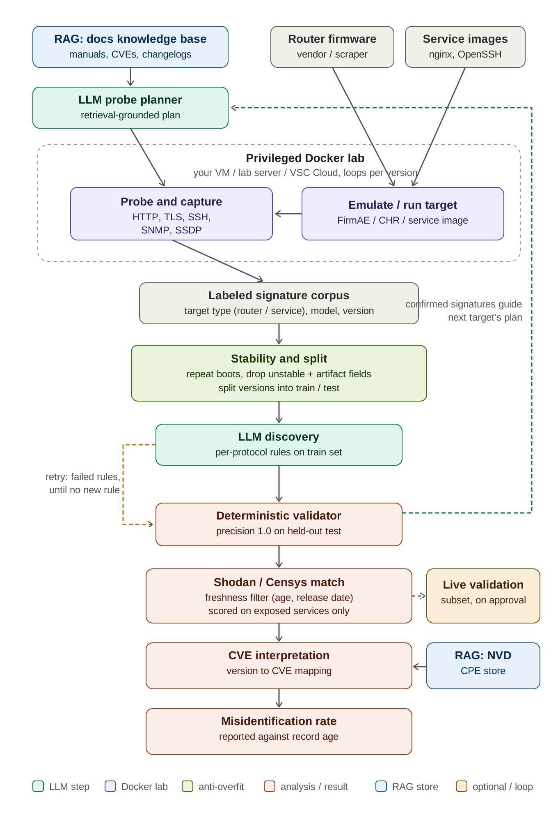

3. The pipeline, stage by stage

Inputs
Two image sources feed the system. Router firmware is obtained from vendor portals or through a scriptable scraper, and service images are obtained from official version-tagged container images such as nginx or OpenSSH. A separate retrieval store holds public documentation: device manuals, published CVE writeups, and firmware changelogs. This store grounds the planner, and it is kept strictly apart from the measured data.

LLM probe planner
For each target model, the planner produces a probe plan, that is, the set of services, ports, and requests worth sending to that specific device. The plan is grounded in retrieved documentation rather than in the model's unaided memory, so each probe can be traced back to a cited source. The planner decides what to ask. It never decides what the answer is.

Privileged Docker laboratory
The laboratory is the only part of the system that requires root and a privileged container, because full-system emulation needs a synthetic network interface and the associated capabilities. Each target is brought up, a router through FirmAE or the CHR image, a service through its official container, and then probed across HTTP, TLS, SSH, SNMP, and SSDP. Traffic is captured alongside the structured responses. Because the version under test is known in advance, every captured record carries a correct label at the moment of capture.

Labeled signature corpus
The per-version records accumulate into a corpus. Each entry is tagged with the target type, router or service, together with the model and the version. The corpus is the material on which discovery operates, since distinguishing one version from another is inherently a comparison across several labeled records rather than an inspection of one.

Stability and split
This stage protects the validity of every claim that follows. It repeats the boot and probe of each version so that any field which varies between boots of the same version is identified as unstable and removed. It strips fields that originate in the emulation environment rather than in the firmware, such as MAC addresses, timestamps, and certificates generated at boot. It then partitions the versions into a training portion, used for discovery, and a held-out portion, used only for confirmation. Without this stage the system would be prone to learning artifacts of its own laboratory.

LLM discovery and deterministic validator
Discovery examines the training portion and proposes per-protocol rules of the form "if this field holds this value, the version is X". The validator applies each proposed rule mechanically to the held-out portion and keeps only those that reach a precision of 1.0. Rules that fail are returned to discovery for a further round, and the loop continues until a round yields no new confirmed rule. Confirmed signatures are additionally fed back to the planner, so that later targets reuse the protocols that discriminated best on earlier ones.

Shodan and Censys match
The confirmed, deterministic signatures are run against the public exposure data. Two guards apply. A freshness filter discards records whose last-seen time is too old or whose timestamp predates the matched version's release. Scoring is restricted to the services that are actually exposed on the public interface, since a device on the internet typically presents far fewer services than the same device in the laboratory.

Live validation (optional, subject to approval)
For a small subset, the laboratory signature is compared against a real deployed or physical device. This step closes the gap between the emulated environment and real deployments. It is marked optional because it depends on ethical and legal approval that is still pending, and it must not be presented as a routine part of the automated loop.

CVE interpretation and final result
The confirmed version is mapped to its vulnerability set through a second retrieval store over NVD and CPE data. The final output is the misidentification rate, reported as a function of record age rather than as a single aggregate number, together with the downstream security consequence of each misidentification.

4. Contributions
Two contributions carry the work. The rest of the pipeline is the methodology that makes them possible, and it is presented as such rather than as novelty in its own right.
- Version fingerprinting of embedded firmware. Prior remote version-identification work targets installable server software, where running the real binary with a known version is straightforward. Embedded firmware is a different problem, since it cannot be installed in the same way, so ground truth must be built through full-system emulation, and a device exposes several protocols at once. The contribution establishes which version transitions are observable from the outside, and under which protocols, and treats the boundary of observability as a result in its own right.
- Quantified downstream vulnerability-attribution error. By mapping each identified version to its vulnerability set and comparing against the labels public scanners assign, the work measures what fraction of hosts receive an incorrect vulnerability attribution because of coarse or wrong version labeling. No prior work has put a number on this propagation, which is the measurement that raises the work from a detection technique to a finding about the security ecosystem.

5. Proposed enhancements to strengthen novelty
The following directions were identified as ways to widen the distance from prior work. They are ranked by expected value, and the recommendation is to pursue a small number deeply rather than all of them shallowly.
- Characterize the observability boundary as a formal result. Build a taxonomy of version transitions that maps which kinds of firmware update produce an observable change and which do not, broken down by cause such as a library bump, a configuration change, or a silent patch. This converts the main risk into a studied phenomenon.
- Exploit multi-protocol fusion. Show that combining weak per-protocol signals yields a strong joint signature when no single protocol suffices. This question is specific to the embedded setting and cannot be posed by a single-service method.
- Study cross-vendor signature collisions. Many devices share the same web stack, such as GoAhead or uhttpd, so two vendors can become indistinguishable. Quantifying where and why public scanners mislabel because of shared components is a root-cause analysis of scanner error, not just a measurement of it.
- Extract negative signatures. Treat the absence of a service or a header as a discriminator, since a feature removed in a newer release is itself a version signal. This adds a dimension that string-matching methods do not use.
- Prove emulation-to-reality transfer. Demonstrate on a validated subset of physical devices that emulated signatures carry over to real deployments. This turns the hardest weakness into a methodological result that the measurement is valid at internet scale.

6. Competitive positioning
Three bodies of work sit close to this one, and each addresses a different slice of the same problem. VersionSeek performs active, low-noise version identification, but on installable server software rather than embedded firmware, and it does not quantify the downstream vulnerability error. The University of Bristol work detects firmware version changes on consumer IoT devices, but passively, from on-path traffic, on a small testbed of twelve devices, and it reaches version-change detection rather than exact version recovery. The firmware-image classification line, represented by the TU Munich study, identifies devices and images, but from possession of the firmware image, which is a whitebox assumption this work deliberately avoids.
A further strand uses language models to label devices at internet scale, inferring the vendor of a device from passively collected metadata. That line stops at vendor identity and lists version inference as future work, so it complements rather than competes with version-level fingerprinting, and it is noted here only to pre-empt the question. The position this work occupies is the intersection that none of the three closest efforts covers at once: embedded firmware, active and blackbox interaction, several protocols fused into one signature, validation at internet scale, and an explicit measurement of the vulnerability-attribution error. The table on the following page makes the separation explicit.

7. Comparison with the closest prior work
Dimension | This work | VersionSeek (USENIX '25) | Bristol TNN (2025) | Firmware-image class.
Target class | Embedded router firmware (primary), network services (secondary) | Five installable server applications | Consumer IoT devices (12 lab devices) | Firmware images, broad device range
Interaction mode | Active, blackbox probing of a live target | Active, low-noise functional probing | Passive traffic observation, no interaction | Static analysis of the firmware image
Access assumption | Remote, no internal access, no image needed | Remote, no internal access | On-path traffic capture on the local network | Possession of the firmware image (whitebox)
Granularity | Exact version, per protocol | Exact version | Version-change detection, not exact version | Device and image classification
Protocol coverage | Multiple protocols fused (HTTP, TLS, SSH, SNMP, SSDP) | The single service protocol per application | Flow statistics across 13 protocols | Not applicable, operates on the image
Use of emulation | Central, builds labeled ground truth at scale | Not required | Not required, real devices in a testbed | Not required, analyzes the image directly
Discovery method | LLM proposal confirmed by a deterministic validator | Human-curated documentation and changelogs | Twin neural network on traffic-derived images | Supervised classification over image features
Downstream CVE link | Explicit, quantified version-to-CVE error | Noted qualitatively, not quantified | Not addressed | Partial, tied to image identification
Scale of validation | Internet scale via Shodan and Censys | Internet scale via Shodan and FOFA | Small testbed, 12 devices over 11 days | Large image corpus, offline
Venue / year | Target: top security venue | USENIX Security 2025 | arXiv 2025 (University of Bristol) | IFIP / academic, earlier work (TU Munich)

Three of these dimensions carry the genuine novelty: the automated discovery loop, the multi-protocol fusion that a single-service target cannot exploit, and the quantified version-to-CVE error. VersionSeek has the active probing and the scale, but not the firmware. Bristol has the firmware, but passively and at small scale. The image-classification work has the firmware breadth, but only under a whitebox assumption.

8. Risks and threats to validity
The risks below are stated so that they can be addressed in the evaluation rather than discovered by a reviewer.
- Intrinsic limit on distinguishability. The architecture can operate flawlessly and still recover few signatures, because many consecutive firmware versions change nothing observable on the wire. This is a property of the problem, not a defect of the method. The honest framing treats the boundary of observability as a reported result. The Bristol work independently observed the same limit, missing one device's version change in every run because the only differences were a random port and a hostname, which supports treating the boundary as a genuine phenomenon.
- Emulation-to-reality gap. A signature taken from an emulated device may differ from the same model as deployed, because of ISP configuration, operator customization, or a different certificate. This is the most exposed weakness, and the optional live validation is the mechanism that addresses it, which is why its optional status is itself a risk to the strength of the claim.
- Staleness of public exposure data. A record held by Shodan may be months old, so an apparent labeling error may instead reflect an outdated snapshot. The freshness filter and the age-stratified reporting separate genuine error from stale data rather than hide the ambiguity.
- NVD leakage in the evaluation. The system both relies on NVD and CPE for the version-to-vulnerability mapping and critiques the accuracy of that same ecosystem. The two roles must be kept separate, so that the ground truth is not drawn from the source under criticism.
- Overfitting to the laboratory. Signatures may latch onto environment artifacts or chance correlations. The stability-and-split stage mitigates this through repeated boots, artifact removal, and held-out confirmation. A further guard is to prefer signatures with a causal explanation, such as a version string in an SNMP sysDescr, over unexplained correlations.
- Dependence on emulation fidelity. If a version boots only partially, its signature is incomplete and may be silently wrong. A health check that confirms the target is fully running must gate the acceptance of any signature from it.
- Documentation dependence of the planner. The planner is only as good as the documentation supplied to it. For obscure models the retrieved material is sparse and the plan weakens. This degrades coverage rather than correctness, since an irrelevant probe merely returns an error.

9. Separation of concerns
Language models appear at two points only, the planner and discovery, and both are advisory. Retrieval stores appear at two points only, planning and CVE interpretation, and both are kept apart from the measured data. The emulate, capture, stabilize, and validate path is deterministic end to end. Version detection itself is decided by confirmed deterministic rules, never by a model and never by retrieved text.

10. Standing conditions
Two conditions govern how far the work can reach. The headline result depends on a distinguishability rate that a controlled pilot has yet to measure, so the strength of the contributions, and the realistic target venue, remain conditional until that pilot is run over a controlled version ladder. The emulation-to-reality transfer should be demonstrated on real hardware for at least a small subset, since without it the bridge from the laboratory to internet-scale data remains assumed rather than shown. The recommended next step is the pilot on a MikroTik and OpenWrt version ladder, from which the distinguishability number will determine the venue and the framing.

